**准备：**

1. Java开发环境(SDK/Tomcat)
2. 安装IDE（IntelliJ IDEA）
3. 以上不做详细说明，请自行百度
4. 参考文章：<https://spring.io/guides/gs/service-registration-and-discovery/>

**搭建spring cloud服务治理平台**

1. 使用IntelliJ IDEA创建spring cloud server项目,[File] -> [New]--> [Project]  
   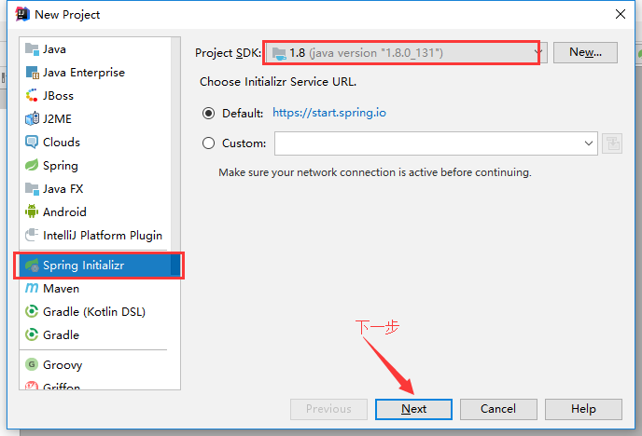  
   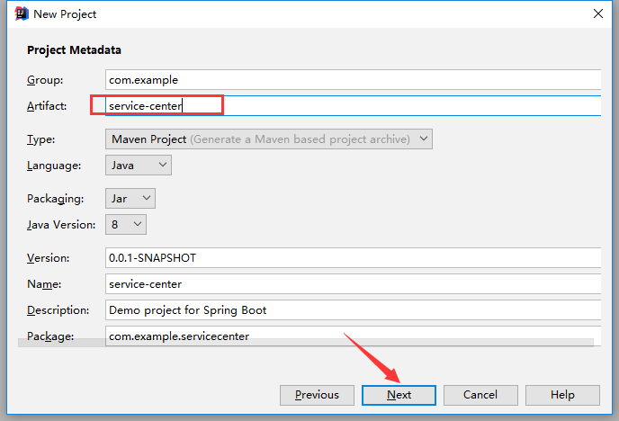  
   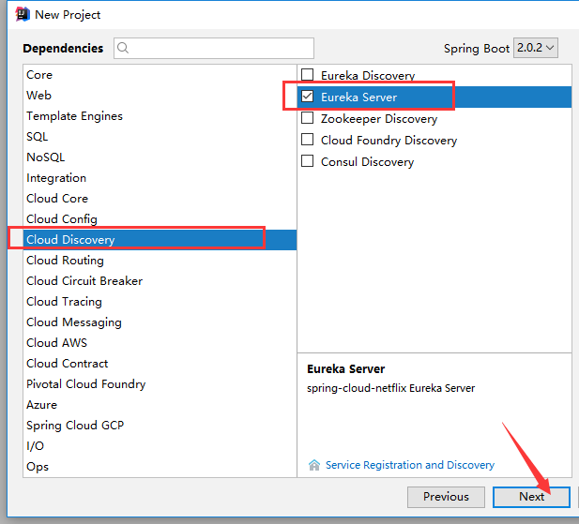
2. 通过上面的步骤，项目已经创建完成，看一下主要的文件：

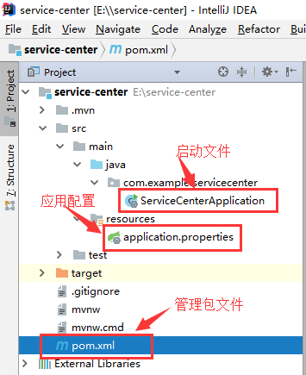

1. 添加spring cloud包依赖，pom.xml文件如下：

*<?***xml version="1.0" encoding="UTF-8"***?>*<**project xmlns="http://maven.apache.org/POM/4.0.0" xmlns:xsi="http://www.w3.org/2001/XMLSchema-instance"  
 xsi:schemaLocation="http://maven.apache.org/POM/4.0.0 http://maven.apache.org/xsd/maven-4.0.0.xsd"**>  
 <**modelVersion**>4.0.0</**modelVersion**>  
  
 <**groupId**>com.example</**groupId**>  
 <**artifactId**>service-center</**artifactId**>  
 <**version**>0.0.1-SNAPSHOT</**version**>  
 <**packaging**>jar</**packaging**>  
  
 <**name**>service-center</**name**>  
 <**description**>Demo project for Spring Boot</**description**>  
  
 <**parent**>  
 <**groupId**>org.springframework.boot</**groupId**>  
 <**artifactId**>spring-boot-starter-parent</**artifactId**>  
 <**version**>2.0.2.RELEASE</**version**>  
 <**relativePath**/> *<!-- lookup parent from repository -->* </**parent**>  
  
 <**properties**>  
 <**project.build.sourceEncoding**>UTF-8</**project.build.sourceEncoding**>  
 <**project.reporting.outputEncoding**>UTF-8</**project.reporting.outputEncoding**>  
 <**java.version**>1.8</**java.version**>  
 <**spring-cloud.version**>Finchley.RC1</**spring-cloud.version**>  
 </**properties**>  
  
 <**dependencies**>  
 <**dependency**>  
 <**groupId**>org.springframework.cloud</**groupId**>  
 <**artifactId**>spring-cloud-starter-netflix-eureka-server</**artifactId**>  
 </**dependency**>  
  
 <**dependency**>  
 <**groupId**>org.springframework.boot</**groupId**>  
 <**artifactId**>spring-boot-starter-test</**artifactId**>  
 <**scope**>test</**scope**>  
 </**dependency**>  
 </**dependencies**>  
  
 <**dependencyManagement**>  
 <**dependencies**>  
 <**dependency**>  
 <**groupId**>org.springframework.cloud</**groupId**>  
 <**artifactId**>spring-cloud-dependencies</**artifactId**>  
 <**version**>${spring-cloud.version}</**version**>  
 <**type**>pom</**type**>  
 <**scope**>import</**scope**>  
 </**dependency**>  
 </**dependencies**>  
 </**dependencyManagement**>  
  
 <**build**>  
 <**plugins**>  
 <**plugin**>  
 <**groupId**>org.springframework.boot</**groupId**>  
 <**artifactId**>spring-boot-maven-plugin</**artifactId**>  
 </**plugin**>  
 </**plugins**>  
 </**build**>  
  
 <**repositories**>  
 <**repository**>  
 <**id**>spring-snapshots</**id**>  
 <**name**>Spring Snapshots</**name**>  
 <**url**>https://repo.spring.io/snapshot</**url**>  
 <**snapshots**>  
 <**enabled**>true</**enabled**>  
 </**snapshots**>  
 </**repository**>  
 <**repository**>  
 <**id**>spring-milestones</**id**>  
 <**name**>Spring Milestones</**name**>  
 <**url**>https://repo.spring.io/milestone</**url**>  
 <**snapshots**>  
 <**enabled**>false</**enabled**>  
 </**snapshots**>  
 </**repository**>  
 </**repositories**>  
</**project**>

1. 添加EnableEurekaServer注解

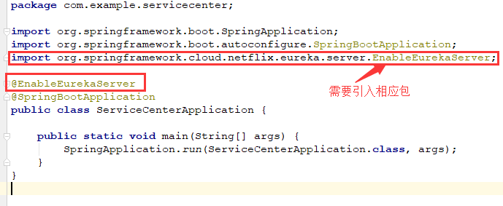

1. 配置程序端口和名称，以及其他配置

**server.port**=**8761**

**spring.application.name=service-center  
eureka.client.register-with-eureka**=**false  
eureka.client.fetch-registry**=**false  
logging.level.com.netflix.eureka**=**ON  
logging.level.com.netflix.discovery**=**ON**

6- 启动项目，浏览http://localhost:8761

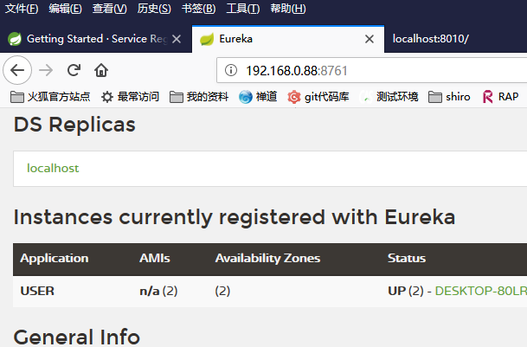

7- 到此，简单的spring cloud服务注册平台已经搭建成功了